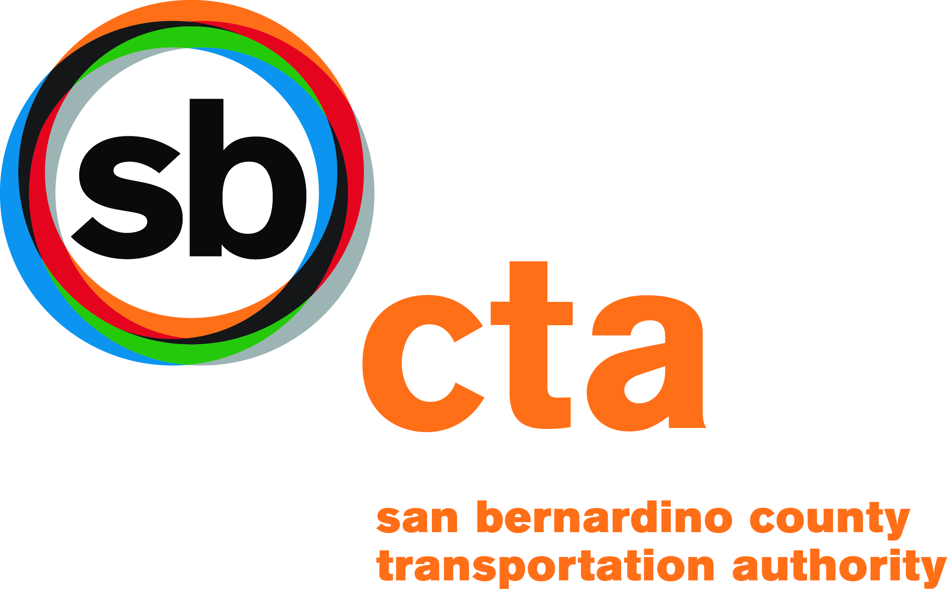 | FTA Section 5310 Expanded Projects  Enhanced Mobility of Seniors and Individuals with Disabilities  Grant Application Instructions  LA/LB UZA for San Bernardino County

Subject | Page(s)
Grant Application Guidelines | 2
Program Overview | 2
Eligibility | 2-4
Mobility Management Projects | 4-5
Performance Measures | 5
Award Amount and Toll Credits /Local Match | 5-6
Project Selection | 6
Application/Program Timeline | 7
General Instructions | 7-8
County OES Address | 9
Project Scoring Criteria | 10

San Bernardino County Transportation Authority
1170 W. 3rd Street, 2nd Floor
San Bernardino, CA 92410

http://www.dot.ca.gov/hq/MassTrans/5310.html

Grant Application Guidelines

Please read all instructions carefully.

These instructions apply to the application for funding under the Federal Transit Administration (FTA) Enhanced Mobility for Seniors and Individuals with Disabilities grant program for the Los Angeles/Long Beach Urbanized Area of San Bernardino County. Requests for funding for Traditional 5310 projects must be submitted on the 5310 Traditional application.

Program Overview

Moving Ahead for Progress in the 21st Century Act (MAP-21)

The new 5310 Program is authorized under the provisions set forth in MAP-21. These provisions authorize the U.S. Secretary of Transportation to apportion funds to each state for grants to this program. MAP-21 also includes a new planning requirement for the 5310 Program, requiring that projects funded through this program “must be included in a locally developed, coordinated public transit-human services transportation plan.”

San Bernardino County Transportation Authority (SBCTA) have elected to administer this grant offering through a Partnership with Omnitrans. SBCTA will select successful projects. Omnitrans will support all other program requirements set forth by the Federal Transit Administration (FTA).

FTA Section 5310 –Expanded 5310 Project Goals

One of the goals for Expanded 5310 Projects is to provide public transportation services to overcome existing barriers facing Americans with disabilities seeking integration into the workforce and full participation into society. Lack of adequate transportation is a primary barrier to work for individuals with disabilities. Expanded 5310 Projects also seek to expand the transportation mobility options available to persons with disabilities beyond requirements of the Americans with Disabilities Act of 1990 (42 U.S.C. 12101, et seq.), as well as alternatives to public transportation that assist persons with disabilities with transportation.

Eligibility

A. Eligible Applicants:

Applicants may include state or local governmental bodies, Metropolitan Planning Organizations (MPOs), Regional Transportation Planning Agencies (RTPAs), social services agencies, tribal governments, private and public operators of public transportation, or an operator of public transportation that receives a Section 5310 grant indirectly through a recipient, and non-profit organizations.

B. Eligible Use of Program Funds:

MAP-21 requires that all Expanded 5310 projects selected for funding be included in a locally developed Coordinated Public Transit-Human Services Transportation Plan (Coordinated Plan). The Coordinated Plan identifies existing services, needs, strategies and priorities for low-income individuals, individuals with disabilities and older adults.

C. Eligible Activities for Expanded 5310 Projects:

Expanded 5310 project funds are available for capital and operating expenses that support public transportation services beyond those required by the Americans with Disabilities Act of 1990 (ADA) and public transportation alternatives beyond those required by the ADA designed to assist individuals with disabilities with accessing transportation services, including transportation to and from jobs and employment support services. Eligible activities include, but are not limited to:

Operating Activities | Capital Activities
- Expansion of paratransit service beyond the minimum requirements of ADA  - Expansion of hours for paratransit service  - Feeder service for intercity travel for which paratransit service is not required  - Enhancement of services (same day; door-to-door; escorts)  - Voucher programs (excludes transit bus pass)  - New or expansion of Volunteer Driver Programs. | - Acquisition of accessibility equipment beyond ADA requirements  - Purchasing accessible vehicles to support taxi, vanpooling, and/or ridesharing programs  - Mobility management activities:  - Planning, development, implementation of coordinated transportation services  - Integration, coordination and promotion of access to transportation services  - Development and operation of one-stop call-center  - Transportation brokerages  - Travel training/trip planning  - Operational planning to acquire IT technologies for coordinated systems

The following is a list of ineligible expenses for 5310 Expanded Projects:

INELIGIBLE EXPENSES FOR 5310 EXPANDED PROJECTS | Comments or Reason if Not Funded
Lease of equipment when lease is more cost effective than purchase. Note that when lease of equipment or for facilities is treated as a  capital expense, the State must establish criteria for determining cost effectiveness in accordance with FTA regulations, “Capital Leases,”  49 CFR part 639 and OMB Circular A-94, which provides the  necessary discount factors and formulas for applying the same. | Staffing resource limitations
Preventive maintenance, as defined in the National Transit Database (NMTD) | Staffing resource limitations
Vehicle rehabilitation; manufacture, or overhaul wheelchair lifts | We purchase new vehicles only
Transit Shelters or other facility improvements | Staffing resource limitations: when federal funds are used, the entire program and land is under federal requirements.
Fixed route equipment such as, but not limited to: fareboxes,  destination signs, stop request system (yellow pull cords), transfer cutters. | This program does not fund  fixed route equipment. The purpose is to meet the special needs of elderly persons and persons with disabilities.

D. Mobility Management Projects

MAP-21 allows projects considered as “mobility management” eligible as a capital expense under the 5310 Program.

- The purpose of mobility management is to integrate and coordinate existing public transportation services with other transportation providers in order to increase the availability of transportation services. Such projects may include, but are not limited to: the planning, development, and implementation of coordinated transportation services; integration, coordination and promotional of access to transportation services; operation of transportation brokerages; the provision of travel training and trip planning services; operational planning to acquire IT technologies for coordinated systems; and the development and operation of one-stop transportation call centers.

- Applicants must provide the following:
- a well-defined operations plan with identified routes, schedules, current/projected ridership, key personnel (attach resumes), and marketing strategies with supporting documentation to accomplish the project.
- an implementation plan that describes project tasks, timeframes, benchmarks, critical milestones, key personnel (attach resumes), deliverables, and estimated completion dates with supporting documentation including:

- Project Start and Completion Date
- Primary Contact Person Name, Phone Number and Email Address
- List the Project Schedule by Months/Year Per Each Task
- Project Task Number
- List Project Tasks, Activities, Deliverables, and Equipment
- Project Team Member Name
- Project Team Member Classification or Title
- Indicate if Project Team Member is Contractor* and/or Existing Staff
- List Number of Project Working Hours (Per Project Task & Per Team Member)
- Identify Full Hourly Rate for Project Team Member (Contractor and/or Existing Staff)
- Equipment Costs for Each Project Task (If Applicable)
- Project Costs for Project Team Members
- Cumulative Costs for Project Team and Equipment Costs

*Consultant Services: Identify what consultant services will be used and describe the bidding process. Contractors must be selected through a competitive selection process per FTA Circular C 4220.1F (November 1, 2008).

- Both the operations and implementation plans must identify assigned personnel and their qualifications. In addition, applicants must demonstrate their institutional capability to perform the service delivery aspect of the project.

Performance Measures

- Expanded 5310 Project Performance Measures

The following indicators will be used to measure project effectiveness:

- Increase or enhancements related to geographic coverage, service quality and or service times that impact availability of transportation services for individuals with disabilities as a result of the Expanded 5310 projects implemented in the current reporting year.
- Additions or changes to environmental infrastructure (e.g. transportation facilities, sidewalks, etc), technology, and vehicles that impact availabilities of transportation services as a result of the Expanded 5310 projects implemented in the current reporting year.
- Actual or estimated number of rides (measured by one-way trips per day) provided for individuals with disabilities as a result of the Expanded 5310 projects implemented in the current reporting year.

Award Amount and Toll Credits/Local Match

- FFY 2015 and FFY 2016 Combined Grant Award Amount (Federal Funds and Toll Credits).

SBCTA may set award limits based on the number of applications received and the availability of funds.

- Local Match (Toll Credits):

Expanded 5310 project funds can be used to support up to 80 percent (80/20 match) capital projects, and not more than 50 percent (50/50 match) of projects for operating assistance. For this grant cycle, (FFY 2015 and FFY 2016), Transportation Development Credits (Toll Credits) will provide the minimum local share for eligible expenditures. Toll Credits may be used to fulfill a project's local share requirement. In essence, this means FTA provides 100-percent of the total combined maximum grant award amount. Toll Credits cannot exceed the local share match percentage.

FTA calculates a project using toll credits as shown in the example:

Actual cost of project: $300,000

Federal Share (80%) $240,000

Local Share (20%) $ 60,000 (from toll credits)

For more information on Toll Credits, visit the Caltrans DRMT website at: http://www.dot.ca.gov/hq/MassTrans/Docs-Pdfs/5311/transittollcreditsrev012611.pdf.

H. Available Funding

Los Angeles/Long Beach UZA Funding

 | Allocation Amount
Fiscal Year 2015 | 368,521
Fiscal Year 2016 | 376,324
Less Omnitrans 4% for Oversight | ($29,794)
Funds Available for Call | $715,051
Maximum for Expanded Program (45%) | $321,773

.

Project Selection Process

I. Project Selection Process

SBCTA will conduct a competitive selection process for Los Angeles/Long Beach Urbanized Area within San Bernardino County. This selection process will be a review and scoring of the Expanded 5310 Project applications before they are forwarded to Omnitrans. SBCTA will verify that each applicant meets all the federal requirements of the grant program. SBCTA is the primary contact for the review and selection process prior to submission to Omnitrans.

Mail your application directly to SBCTA. Your application must be received no later than March 1, 2017.

J. Responsibility of Grant Subrecipient

When any agent other than the subrecipient in the grant application operates vehicles or other equipment, control and responsibility for the operation of the vehicles must remain with the grant subrecipient. The subrecipient agency will remain as the registered owner of the vehicle and will be responsible for program compliance including but not limited to operation oversight, reporting, insurance, maintenance and monitoring until useful life standards are met.

Application/Program Timeline

K. Application/Program Timeline

Dates | Activity
January 4, 2017 | Call for Projects
March 1, 2017 | Applications due to SBCTA
May 3, 2017 | SBCTA Board Approves Section 5310 Awards
May – August 2017 | Projects submitted to FTA, Successful Applicant Workshop, Agreements

General Instructions

1. APPLICATIONS DUE to SBCTA:

MUST BE RECEIVED BY: March 1, 2017

2. ALL APPLICATIONS ARE DUE TO:

San Bernardino County Transportation Authority (SBCTA)
Attn: Nancy Strickert
1170 W. 3rd Street, 2nd Floor
San Bernardino, CA 92410

MUST BE RECEIVED BY: March 1, 2017

3. Applicant must submit to SBCTA three (3) copies (one original plus two copies) of the application and one (1) electronic copy (either Microsoft Word or PDF, Including attachments).

4. Mark “ORIGINAL” on the cover of your application package, which contains the master copy of the requested documentation with original signatures.

Early coordination with your SBCTA representative is encouraged.

5. Applications must be complete and final. No amendments or supplements to the application will be accepted.

Note: Application packages with incomplete and/or missing information will not be considered for funding.

6. The application format is provided in a MS Word or pdf format. An electronic version of the application form is at our website.

7. To prepare the application using a “hard copy (without a computer), all documentation should be included in a distinctly labeled second part of your application labeled as the “Appendix.” Your narrative should mention specific documentation and include a reference to where it can be found in your “Appendix.” Narrative responses should be complete and concise.

8. Public Record

Section 5310 application materials and attachments are not considered confidential by SBCTA or Omnitrans. Therefore, applicants should not include confidential information, such as client names, addresses, specific medical diagnosis, telephone numbers, and times the clients are scheduled to be transported. This kind of information should be redacted from client lists. You should be aware, however, that too little information may not adequately document your client’s needs that are necessary for an application to be properly scored.

County OES Address

San Bernardino County Office of Emergency Services
1743 W. Miro Way
Rialto, CA 92376
(909) 356-3998
(909) 356-3965 fax
After-Hours Emergency Only Contact Number: (909) 356-3805

PROJECT SCORING CRITERIA

To receive the maximum points, response to each question must be completed with clear and concise information and contain the required supporting documentation. Incomplete responses and/or a lack of supporting documentation will result in reduced score(s).

- Program Goals and Objectives - (20 total points):
- Applicant demonstrates that the project is consistent with the overall Expanded 5310 project goals and objectives, as listed in the program goals on Page 2 of these instructions.
- Applicant demonstrates how project activities directly address transportation gaps and/or barriers identified through the locally developed human services transportation planning process within their communities. (Applicant indicates the section/page number in the Coordinated Plan addressing the gaps and/or barriers).

- Project Implementation Plan - (30 points):
- Applicant provides a well-defined operations plan with defined routes, schedules, current/projected ridership, key personnel, and marketing strategies with supporting documentation for carrying out the project. For Capital projects, applicant provides an implementation plan that includes project tasks, timeframes, benchmarks, key milestones, key personnel, deliverables and estimated completion date with supporting documentation. Describe type of equipment you are interested in purchasing and identify the components. Discuss how the requested ancillary equipment will be used to support the transportation program. Discuss any expected improvements in service delivery or coordination and any reduction in the cost to provide service. If computer equipment is being requested, also describe current method of collecting and tracking information. Both the operations and implementation plans must identify key personnel assigned to this project and their qualifications, including resumes and certifications as supporting documentation. Applicants must demonstrate their institutional capability to carry out the service delivery aspect of the project.

- Program Performance Indicators - (20 points):
- Applicant identifies clear measurable outcome-based performance measures and indicators to track the effectiveness of the project as described in Page 6 of these instructions. Applicant states the number of persons to be served, trip purpose(s), and the number of trips. Additional measurable units of service can also be used. Applicant must describe the outcome (impact) that the project will have on seniors and individuals with disabilities.
- Applicant describes a process that details the ongoing monitoring and evaluation of the project or service, including methodologies and desired outcomes based upon the performance objectives identified.

- Communication and Outreach - (20 total points):
- Stakeholder list should include, but not be limited to, Health and Human Services Agencies, public/private sector, non-profit agencies, transportation providers, and members of the public representing seniors and individuals with disabilities. Applicants will be evaluated based on their ability to coordinate with other community transportation and/or social service resources.
- Applicants must keep stakeholders involved and informed of project activities throughout the project timeline. Applicant must also describe how they would promote public awareness of the project. Three (3) letters of support from stakeholders must be attached to the grant application. (One of the three support letters may come from a client of the proposed project.)
- Emergency Planning and Preparedness - (10 total points):
- Applicant describes emergency planning and drill activities. Provide proof your agency is included in the response plan with the County Office of Emergency Services. Indicate the drill(s) you have participated in or are scheduled to participate in.

