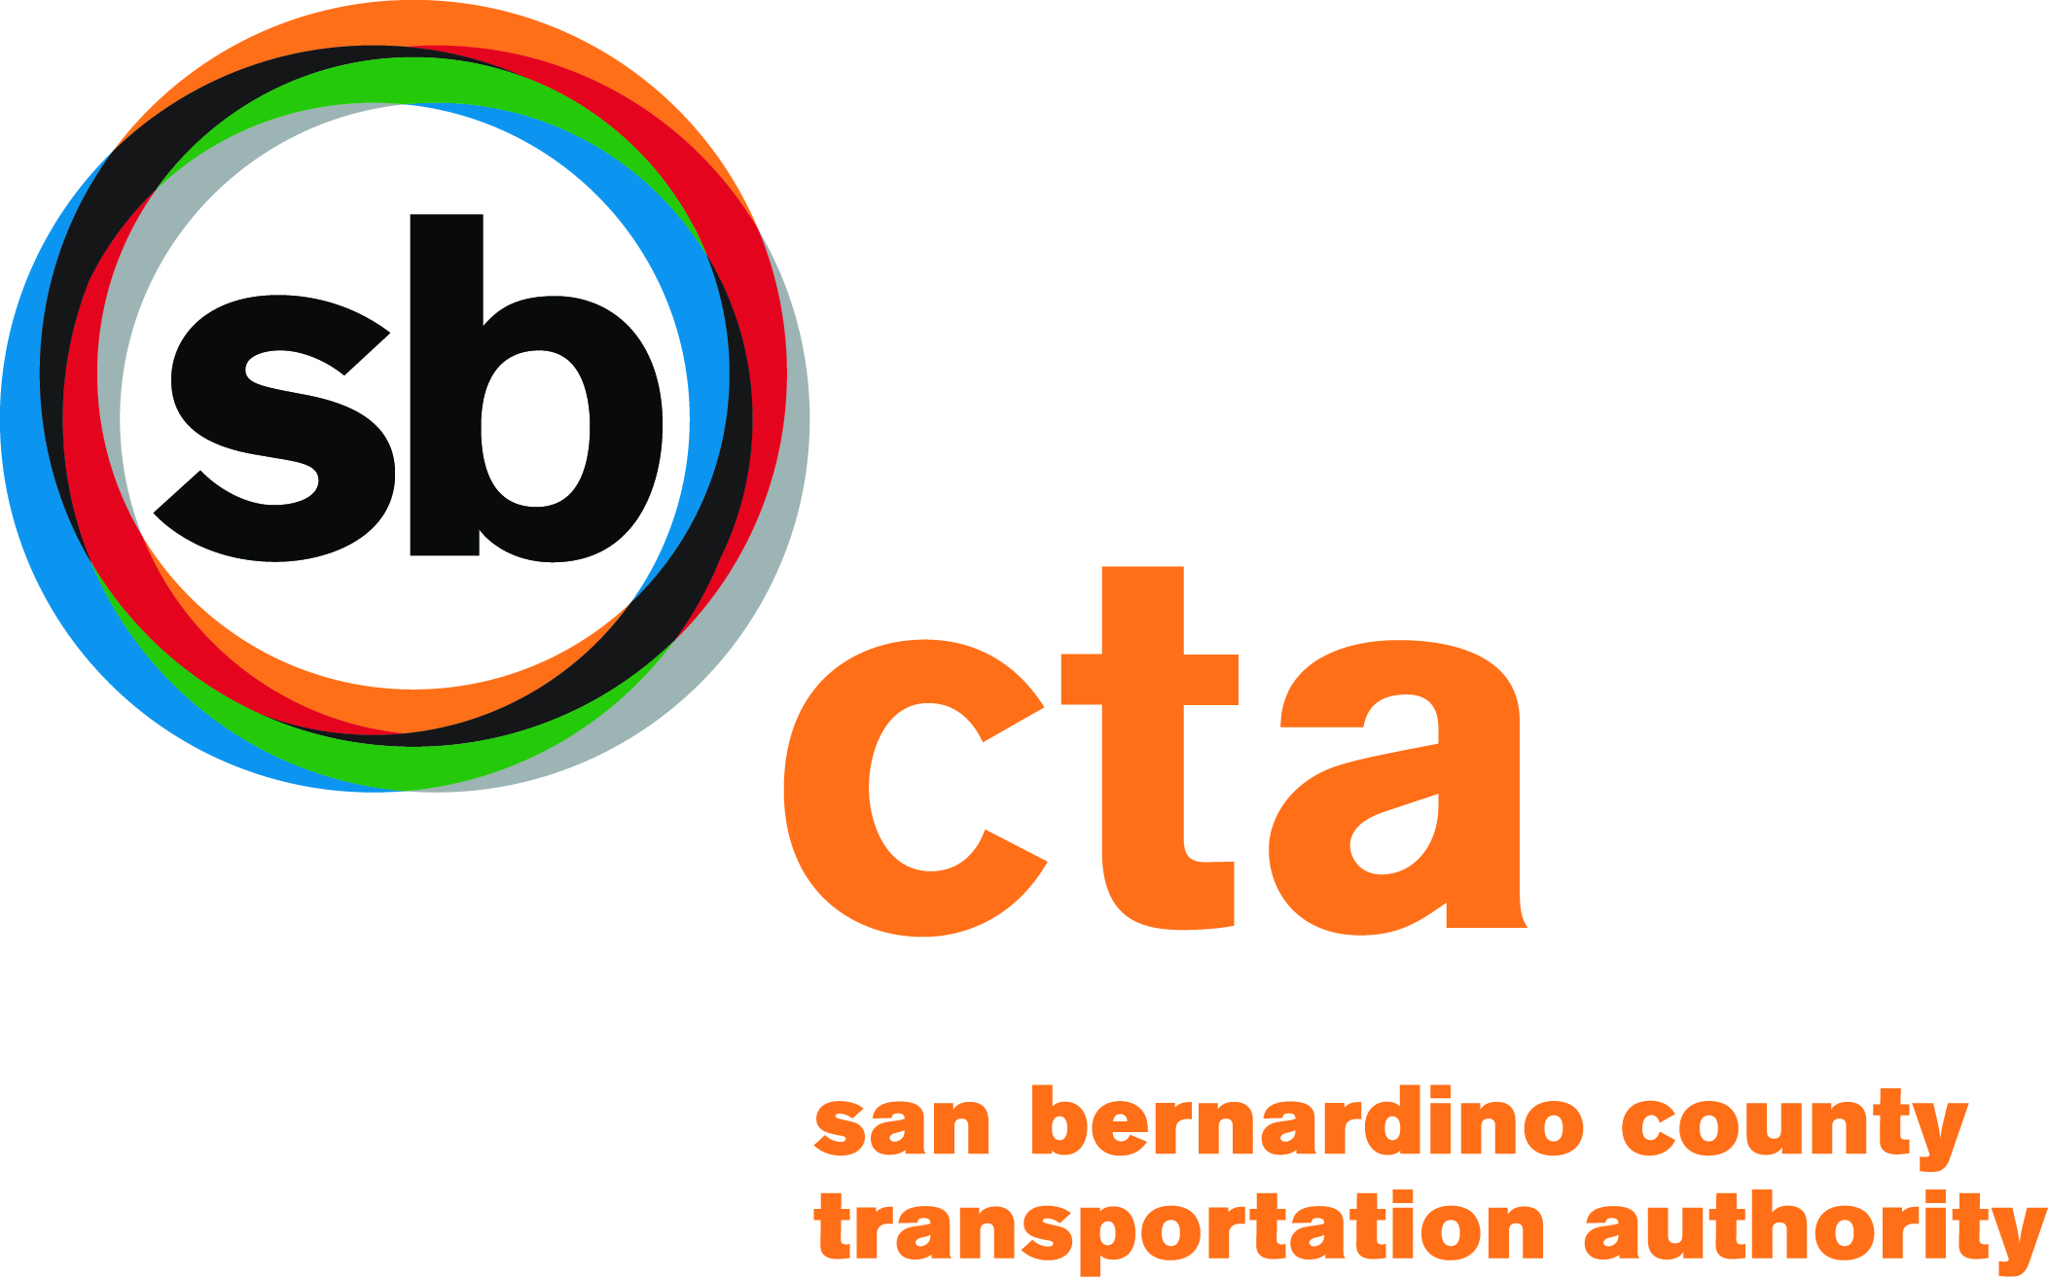 | FTA Traditional 5310 Projects  Enhanced Mobility of Seniors and Individuals with Disabilities  Application Instructions for LA/LB UZA for San Bernardino County

The following is a list of the application questions that are addressed in these instructions. Not all questions in the application require additional instructions.
 | Page
General Instructions | 3
Coordinated Plan (Application Page 3) | 4
Public Agencies (Application Page 7) | 4
Eligible Capital Expenses (Application Page 14) | 5
Ability of Applicant (Application Page 18)………………………. | 8
Proposed Budget for Transportation Program (Application Page 21) | 8
Existing Transportation Services (Application Page 25) | 9
Glossary | 10

San Bernardino County Transportation Authority (SBCTA)
1170 W. 3rd Street, 2nd Floor
San Bernardino, CA 92410

More information:
http://www.dot.ca.gov/hq/MassTrans/5310.html
Toll Free Hotline 1.888.472-6816

Grant Application Guidelines

Please read all instructions carefully.

These instructions apply to the application for funding under the Federal Transit Administration (FTA) Enhanced Mobility for seniors and Individuals with Disabilities grant program for the Los Angeles/Long Beach Urbanized Area of San Bernardino County. Requests for funding for Enhanced Mobility 5310 projects must be submitted on the 5310 Enhanced Mobility application.

Program Overview

Moving Ahead for Progress in the 21st Century Act (MAP-21)

The new 5310 Program is authorized under the provisions set forth in MAP-21. These provisions authorize the U.S. Secretary of Transportation to apportion funds to each state for grants to this program. MAP-21 also includes a new planning requirement for the 5310 Program, requiring that projects funded through this program “must be included in a locally developed, coordinated public transit-human services transportation plan.”

San Bernardino County Transportation Authority (SBCTA) has elected to administer this grant offering through a Partnership with Omnitrans. With SCAG’s approval, SBCTA will select successful projects. Omnitrans will support all other program requirements set forth by the Federal Transit Administration (FTA).

GENERAL INSTRUCTIONS
Please read all instructions carefully.
- Mark "ORIGINAL" on the cover of your application package that contains the master copy of the requested documentation with original signatures.
- Submit the original application, three photocopies, and one electronic copy (i.e., CDs, flash drives, etc.) to SBCTA by 5pm on March 1, 2017. Please note: The entire application and all appendices must be included in the electronic copies.
Additional copies may be requested by SBCTA.
Early coordination with your SBCTA representative is encouraged.

SBCTA will:
  - Establish the applicant’s eligibility (Part 1 of the application).
  - Review the application for completeness and contact the agency for questions and clarification for improvement.
  - Review and score the application.
  - Forward to Omnitrans the original and one electronic copies of the application, the Quantitative Scoring & Project Rating Worksheets, and regional priority list of projects.

- Applications must be complete and final. No amendments or supplements to the application will be accepted after the SBCTA due date of 5pm on March 1, 2017.
Note: Application packages with incomplete and/or missing information will not be considered for funding.
- The application format is provided in an MS Word document. An electronic version of the application form is at our website: www.SANBAG.ca.gov
To prepare on a computer: Insert additional space where needed to complete questions (e.g., application form page 8, continuing pages should be numbered 8a, 8b, 8c).
- To prepare the application using a “hard copy” (without a computer):
Use application forms as provided. If additional pages of narrative are needed, insert them immediately following the page on which the narrative started, indicating their order alphabetically (e.g., application form page 8, continuing pages should be numbered 8a, 8b, 8c).
All documentation should be included in a distinctly labeled second part of your application labeled as the “Appendix.” Your narrative should mention specific documentation and include a reference to where it can be found in your appendix.
- Narrative responses should be complete and concise. All questions must be answered. N/A responses will be considered incomplete.
- Review the glossary sheet on page 10 of these instructions for terms used throughout the application.

Public Record
Section 5310 application materials and attachments are not considered confidential by SBCTA or Omnitrans. Application contents and attachments received by SBCTA are considered public records. Therefore, applicants should not include confidential information such as client names, addresses, specific medical diagnoses, telephone numbers, and times the clients are scheduled to be transported. This kind of information should be redacted from client lists. You should be aware, however, that too little information may not adequately document your clients’ needs that are necessary for an application to be properly scored.
Use of Vehicles
Vehicles acquired under the Section 5310 program must be used primarily for elderly persons and/or persons with disabilities at a minimum of 20 service hours per week per vehicle. Services are to be provided only within the legal jurisdiction of the grantee. Vehicles may be used only in the following ways:
- By the private non-profit organization or the public agency as described in their approved grant application;
- By a private for-profit operator, via contractual agreement with the successful applicant only for the services identified in the approved grant application. The contractual agreement must be pre-approved by SBCTA and Omnitrans.
Responsibility of Grant Subrecipient
When an agent other than the subrecipient in the grant application operates vehicles or other equipment, control and responsibility for the operation of the vehicles must remain with the grant subrecipient. The private non-profit organization or public agency remains the registered owner of the vehicle and remains fully responsible for program compliance including, but not limited to, operation oversight, reporting, insurance, maintenance and monitoring.

PART I – APPLICANT ELIGIBILITY _________________________
See Application - Coordinated Plan Certification – Page 3
Both the SBCTA (Agency preparing the Coordinated Plan) and the Grant Applicant shall sign this form. (Grant Application, page 3).
Individual projects and/or agency names are not required to be listed in the Coordinated Plan as long as the strategy for the project is included the Coordinated Plan.

See Application - Public Agencies Page 7
Public agencies must meet either "a" or "b" below and submit required documentation:
a. In order to make a determination that no non-profit agencies are readily available (see glossary) to provide the proposed service, a public agency must provide substantial written proof (as identified on page 7 of the Application) documenting the exceptional circumstances that no non-profit agencies are readily available to provide the proposed service.
A public agency must hold a public hearing between the release date of the call for projects and the application due date to SBCTA. Notice of the hearing, including the date, place, and specific purpose, must be given at least 30 days in advance through publication in a newspaper of general circulation.
Note: If the public hearing has not been held prior to the application’s submittal to SBCTA, then proof of publication and hearing must be submitted to both Omnitrans and SBCTA prior to the final application due date to Omnitrans.
A public agency must contact all non-profit transportation providers (as may be identified by SBCTA, the local CTSA, the Coordinated Plan and/or Omnitrans) regarding the hearing by a "return receipt requested" letter.
A public agency must adopt by resolution a finding that there are no non-profit agencies readily available to carry out the proposed service. A copy of this resolution must be included as an appendix to the application. If during the hearing a private non-profit agency demonstrates that it is able to provide the proposed service, the public agency is no longer eligible to apply for Section 5310 funds.
For information on the appeal process refer to the Program’s State Management Plan located at: http://www.dot.ca.gov/hq/MassTrans/5310.html

PART II - FUNDING REQUEST
See Application - Eligible Capital Expenses - Page 14
Unit Cost Estimates and Other Equipment
The vehicle unit cost includes the cost of a base accessible vehicle that includes a wheelchair lift, tie downs, an estimate of the procurement fees and applicable sales tax associated with the vehicle purchase. Applicants are to use the unit costs as provided on the application form.
Requests for “other equipment” in the Grant Application page 12 (e.g., computer systems, dispatching and tracking software, telecommunication systems) that support the transportation program are limited to $40,000 for the entire request, with a minimum cost of $1,000. Cellular phones, pagers and service subscriptions, and fixed route equipment are not eligible for funding.
When requesting computer hardware or software, or other equipment, list the specific items to be purchased and provide three informal estimates of requested equipment costs with the application. Estimates can be copies from Internet sites, advertisements, or product catalog. The average of the three (3) like-kind estimates will become the grant amount placed in the “Unit Cost” space provided.
Request Limitations
The San Bernardino County Transportation Authority (SBCTA) may set award limits based on the number of applications received and the availability of funds.

Available Funding

All applicants must serve the Los Angeles/Long Beach UZA

 | Allocation Amount
Fiscal Year 2015 | $368,521
Fiscal Year 2016 | $376,324
Less Omnitrans 4% for Oversight | ($29,794)
Funds Available for Call | $715,051

Note that at least 55% of the funds available must be awarded to Traditional 5310 Projects.
ELIGIBLE CAPITAL EXPENSES (excludes mobility management) | Funded | Not Funded | Comments or Reason if Not Funded
Buses and vans (including baseline vehicle equipment) | x |  | Must be ADA accessible/No Sedan or SUVs
Vehicle procurement testing, inspection, and acceptance costs | x
Wheelchair restraints | x
Radios and communication equipment (excludes cell phones and service agreements) | x
Initial component installation costs | x
Computer hardware and software (scheduling and dispatch software) | x |  | In support of 5310 program purposes only. Public transit services not eligible.
Extended warranties which do not exceed the industry standard | x |  | At the time of purchase only.
Transit related intelligent transportation systems (ITS); and the introduction of new technology, through innovative and improved products, into public transportation | x |  | Regional ITS Architecture Plan required at time of application. See www.dot.ca.gov
Acquisition of transportation services under a contract, lease, or other arrangement. Both capital and operating costs associated with contracted service are eligible capital expenses. User-side subsidies are considered one form of eligible arrangement. The State, as recipient, has the option to decide whether to provide funding for such acquired services. Funds may be requested for contracted services covering a time period of more than one year. The capital eligibility of acquisition of services as authorized in 49 U.S.C. 5310(a)(3) is limited to the Section 5310 program |  | x | We fund the equipment/capital costs and allow contracted services as long as there is a State approved MOU. Excludes operating costs.
Lease of equipment when lease is more cost effective than purchase. Note that when lease of equipment or facilities is treated as a capital expense, the State must establish criteria for determining cost effectiveness in accordance with FTA regulations, “Capital Leases,” 49 CFR part 639 and OMB Circular A–94, which provides the necessary discount factors and formulas for applying the same |  | x | Staffing resource limitations
Preventive maintenance, as defined in the National Transit Database (NTD) |  | x
Vehicle rehabilitation; manufacture, or overhaul  Wheelchair lifts |  | x | We purchase new vehicles only.
Transit Shelters or other facility improvements |  | x | Staffing resource limitations, when federal funds are used, the entire program and land is under federal requirements.
Fixed route equipment such as, but not limited to: fareboxes, destination signs, stop request system (yellow pull cords), transfer cutters. |  | x | This program does not fund fixed route equipment. The purpose is to meet the special needs of elderly persons and persons with disabilities.

PART III – SCORING CRITERIA _____________________________________________
See Application – Scoring Criteria – Ability of Applicant, Page 18 &
Quantitative Scoring and Project Rating Worksheet, Section I
Before answering the questions in this section, review the related criteria on the “Quantitative Scoring and Project Rating Worksheet.” This helps in understanding the focus of the items to be scored. Attach documentation that supports your answers (examples provided below) as an item in your Appendix.
Note: Applicants who address questions completely and discuss the relevance of the attached documentation that supports the stated transportation needs will earn full points.
- Testimony at, or findings from, a TDA Article 8 hearing (Unmet Transit Needs)
- Citizen on-board passenger surveys
- Current waiting lists and/or records of trips denied
- American with Disabilities Act (ADA) Plan
- Recognized surveys
- Recognized studies or plans that document transit needs (e.g., Area Agency on Aging Needs Assessment, short range transit plan, Senate Bill 826 Action Plan/Progress Report),
- Letter from public transit agency
- Newspaper articles
- Agency brochures, agency statistics or demographics
- Letter of inquires to and/or response from other funding sources.
See Application - Proposed Budget for Transportation Program – Page 21
1. Annual Operating Budget: (Application Question 10, page 18)
Indicate the proposed annual operating budget for your entire transportation program, including the costs associated with operating the requested equipment.
2. Operating Fund Sources: (Application Question 11, page 18)
You must include, and explain, all sources of operating revenue; including revenue from grants, donations, and local fund-raising projects that will be used to fund your transportation program. List the funding sources and amounts for the prior, current and budget year. The total sources of operating funds in Question 10, “Operating Fund Sources,” should be equal to the total operating income shown in Question 11, “Annual Operating Budget.”
3. Local Match: (Application Question 12, page 18)
Toll credits are being applied to meet the local share (20%). Specify the amount in the space provided.

See Application – Existing Transportation Services – Page 25
Information to complete this chart (Note: The gray band on the chart provides a sample entry.)
- List the Vehicle Vin # for each vehicle in your Existing Transportation Services.
- Proposed Replacement requests only: Indicate the type of vehicle, Van or Bus for vehicles proposed for replacement in the application. A van is defined as a vehicle with a gross vehicle weight rating (GVWR) of less than 10,000 pounds; and a bus as a vehicle with a GVWR of more than 10,000 pounds, as identified by the Original Equipment Manufacturer’s weight certificate located on the driver’s side door. Also indicate the disposition of the vehicle proposed for replacement as follows: “BK” for backup and “S” for sell. To be eligible for replacement, vehicles must meet the following criteria at the time the application is filed:
- Vehicle to be replaced must be currently registered to the applicant and in active service (providing service throughout the agency’s normal days and hours of operation)
- Vehicle to be replaced is for a like-kind vehicle with similar service life. See page 13 of application.Sedans and SUVs are not eligible for replacement.
- List all active vehicles years and makes in your fleet inventory.
- List the most current mileage in your fleet available prior to filing the application.
- List ambulatory (A) seating capacity and wheelchair (W) capacity (e.g. 6A/2W) for each vehicle.
Indicate the number of fold down seats in the wheel chair positions for each vehicle. Identify, by indicating “Y” for yes and “N” for no, if a vehicle is currently used as a backup vehicle. Note: vehicles currently in backup service are not eligible for replacement.
- Date the vehicle was purchased or leased by your agency.
- List the registered owner(s) of the vehicle. Do not list the legal owner (lien holder). You may abbreviate or use the words "applicant,” “county," etc., where the meaning is clear in the context of the application
- List number of hours per day, excluding idle time (see glossary), that each vehicle provides service. Then, total the service hours per day for all active vehicles (exclude backups) in the fleet and enter the total in the last cell in column 10. Use whole numbers of hours, not ranges of hours, or portions of hours.
- List average number of one-way passenger trips (see glossary for definition) per day. Provide total number of one-way passenger trips per day for all active vehicles (exclude backups) in the fleet by totaling all entries and enter the total in the last cell in column 11. Do not use ranges.
- Annual maintenance and repair costs. List total maintenance and repair costs for the last 12-month period for which figures are available.

FTA SECTION 5310 GLOSSARY
ADA | Americans with Disabilities Act, this Federal law is a comprehensive civil rights measure prohibiting discrimination against the disabled in employment, housing and transportation. The intent of ADA is to ensure equal access for persons with disabilities to public accommodations, public services, telecommunications and transportation.
Appropriate Funds | All local shares must be provided from sources other than Federal funds except where specific legislative language of a Federal program permits its funds to be used to match other Federal funds.
Backup Vehicles | Backup vehicles are defined as vehicles that are used from time-to-time, not on a daily basis to provide service.
Bus | Vehicle with a gross vehicle weight rating of more than 10,000 pounds as identified by the Original Equipment Manufacturer’s weight certificate located on the driver’s side door.
CTC | An acronym for California Transportation Commission. The body established by State law to advise and assist the Secretary of the Business, Transportation and Housing Agency and the Legislature in formulating and evaluating state policies and plans for transportation programs. The CTC is responsible for adopting the annual listing of approved Section 5310 projects before forwarding to FTA for approval.
CTSA | An acronym for Consolidated Transportation Service Agency. Local agency designated by the Regional Transportation Planning Agency to consolidate and coordinate social service transportation.
FTA | An acronym for Federal Transit Administration. Federal level agency, which administers the Federal Transit Act, as amended, and specifically provides funding to the states for the Section 5310 program.
Idle Time | Idle time generally means the time the vehicle is not in direct passenger service.
One-way Passenger Trips | One-way passenger trips are counted as each time a person boards the vehicle, so that a round trip would be counted as two passenger trips
Readily Available | Readily available is defined as willing, interested and capable of providing the proposed service at a comparable cost to the identified clientele in the same service area, with the same hours of frequency, and at the same level of service.
RTPA | An acronym for Regional Transportation Planning Agency. Local agency responsible for transportation planning activities and allocating of transit funds in a specified region. RTPAs can be Local Transportation Commissions, Councils of Governments, Metropolitan Planning Organizations or statutorily created agencies.
Unqualified Audit Opinion | An acceptable audit, indicating that the agency is in compliance with generally accepted accounting principles. Note: any other type of opinions, e.g., “qualified with exceptions,” “reportable conditions,” “material weaknesses,” “noncompliance with requirement,” will be evaluated on a case-by-case basis.
Van | Vehicle with a gross vehicle weight rating of less than 10,000 pounds as identified by the Original Equipment Manufacturer’s weight certificate located on driver’s side door.

